Assessment

1. Open One Drive in your system / or log on to <https://www.office.com/>

* Open <https://www.office.com/> on your internet browser
* You can also open OneDrive in your system.

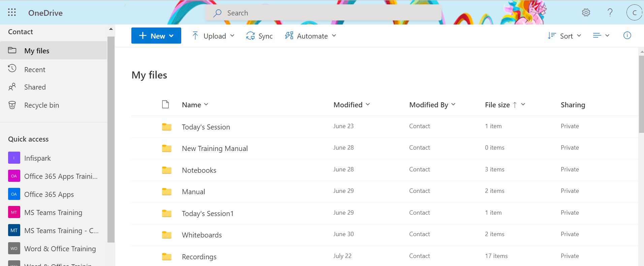

1. Create Folders of all the assignments that you have completed

* Go to New and click on the drop-down menu
* Click on Folder
* A dialog box will appear to name the folder
* Name the folder Assessment and then click on Create

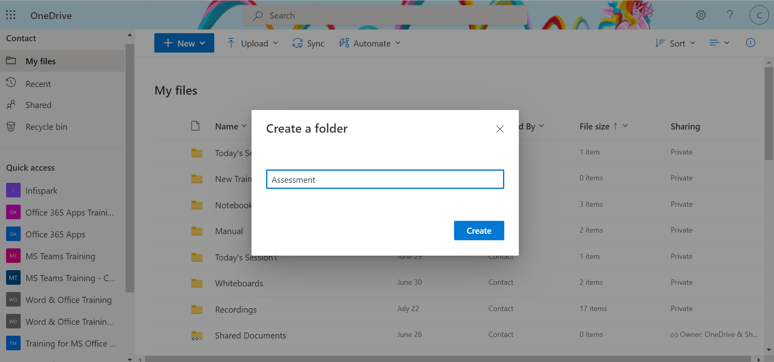

1. Upload all the screenshots in the designated folders

* Click on the folder Assessment
* Go to Upload and click on the drop-down menu
* Upload the Screenshot file from your desktop/system
* Wait for a few minutes as the file/ files get properly uploaded to your desktop.

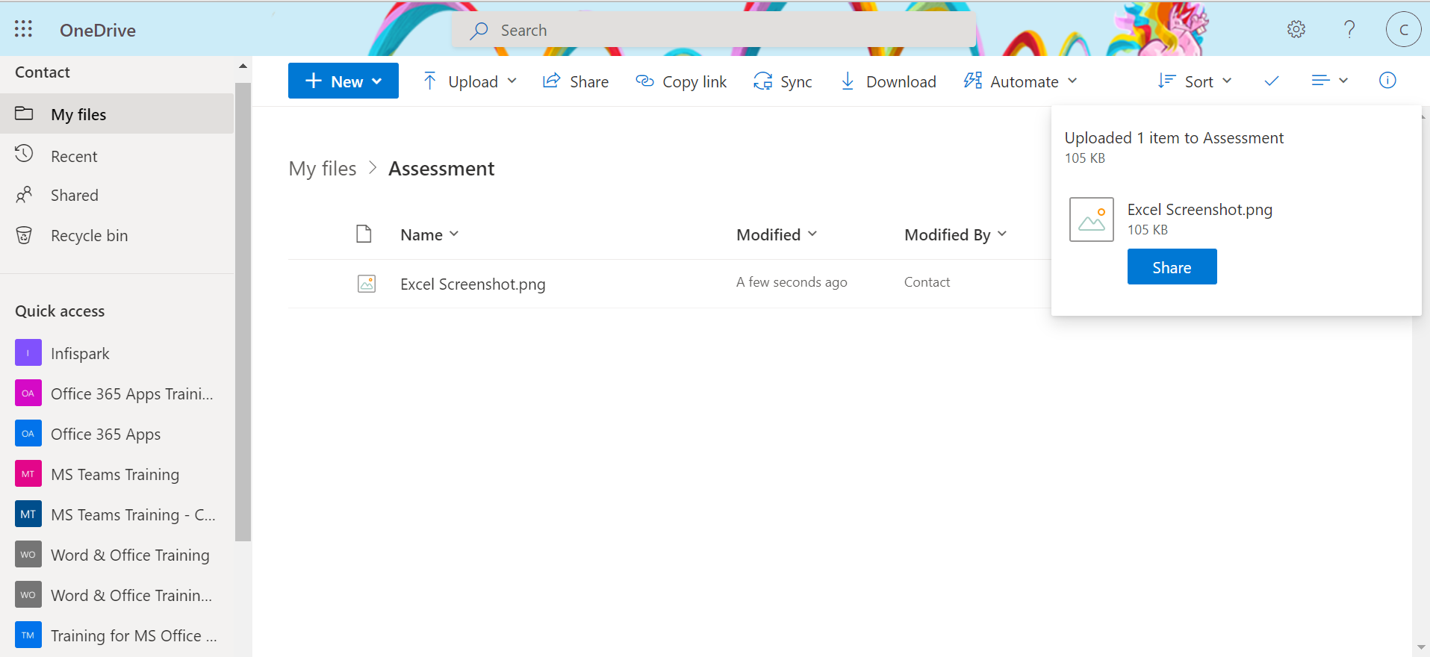

1. Share the folders with your team

* Select the file
* Three dots will appear just beside the file, click on to it.
* A drop-down menu box will appear and you can select Share from the option
* Once you click on Share, a dialog box will appear from where you have to choose your desired setting i.e., with whom you want to share the folders with
* Add their email ids and then click on Send.

